**KAICOIN Main Contents**

Convergence of Blockchain and Culture

Massive Scale Test of KAICOIN

Experience the Blockchain Platform in Day-to-Day Life

Initial Coin Offering (ICO) participation to be closed on October 31, 2017 (GMT+9)

---------------------------------------------------------------------------------------------------------

“A Convergence of Blockchain and Korean Cultural Contents Enters Your Daily Life!”

Korea is a powerhouse in the Information Technology (IT) sector which, because of its fast and systematic Information and Communication Technology (ICT) infrastructure, has a promising future. In a world where distributed servers are gaining importance, we are producing tangible results by supporting social, cultural, and economic activities through our business and social contribution platforms. We have also identified problems that cyber currency entails and are researching and developing proper solutions.

---------------------------------------------------------------------------------------------------------

1. Society

Expand social infrastructure by sharing blockchain technology

Support not-for-profit and non–governmental organization (NGO) activities by setting up a social contribution platform for transparent funding

2. Culture

Build a marketing platform that targets the Chinese and Japanese markets with K–culture contents

Expand the use of virtual reality (VR) contents and mobile video navigation

Connect restaurants, travel agencies, and clinics into an off-line network

Expand support for domestic/international online shopping malls

Support exchanges of items within an online game platform

3. Economy

Build KAIREX—an integrated KAICOIN Trade House

Allow the use of KAICOIN on automated teller machines (ATMs)

Register KAICOIN on the C-CEX

---------------------------------------------------------------------------------------------------------

KAICOIN forms a platform for Blockchain, which can be utilized in numerous ways in our daily activities.

It will make a great contribution to society by combining unique Korean contents and will become an internationally exchanged cyber currency.

---------------------------------------------------------------------------------------------------------

About KAICOIN

With the advent of virtual coins, people have a new opportunity to build assets.

In order to dramatically resolve economic inequality and its subsequent social costs

by letting more people share returns from financial assets,

virtual currency (cryptocurrency) has been developed.

KAICOIN is a result of the optimum balance found in

the evolving security algorithms and properties, which

removed shortfalls in Bitcoin and Ethereum (ETH).

KAICOIN was developed and issued by Kaii.

KAICOIN is the ultimate solution to the problems of existing virtual currencies because it improves the mining process. It also changed user interface and the level of effort that goes into making profit.

Based on its benefits, KAICON will soon become a versatile cyber currency,

which is freely used globally in the cultural/economic/social arena.

---------------------------------------------------------------------------------------------------------

KAICOIN Specifications

| **Item** | **Description** |
| --- | --- |
| Coin Name | KAICOIN |
| Unit | KAI |
| Presale Period | September 1, 2017; 12 p.m. – October 31, 2017; 11:59 p.m. (GMT+9) |
| Price per Token | KAI 1,500=ETH 1 |
| Minimum Purchase | From KAI 150=ETH 0.1 |
| Total Availability | 200 million |
| Currency | ETH |

---------------------------------------------------------------------------------------------------------

KAICOIN Share Structure

Advance Mining Volume

Total Volume Available

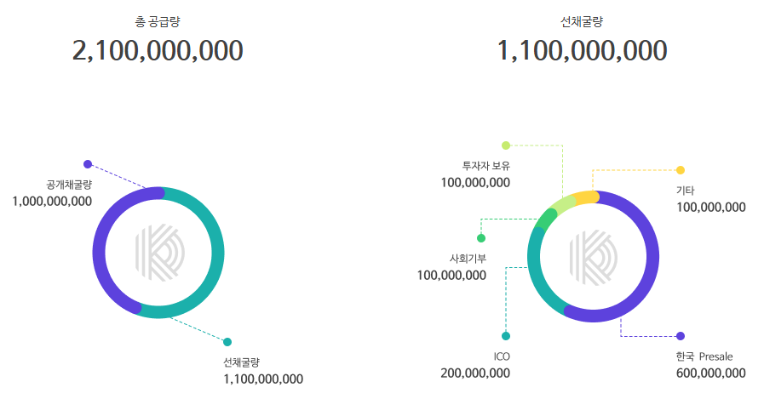

Korea Presale

Others

Social Contribution

Owned by Investors

Owned by Investors

Advance Mining Volume 1,100,000,000

Open Mining Volume

1,000,000,000

---------------------------------------------------------------------------------------------------------

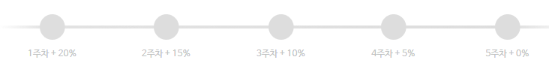

Road Map

–September 2017

Online: Develop KAICOIN / complete ICO Korea presale/launch ICO global presale/sign KAICOIN donation agreement.

Off-line: Set up off-line merchant agreement with restaurants, clinics, and credit card providers.

Usage Area: Pickle service / investment attraction in the movie industry / game item purchase / online shopping mall / form an alliance with Ediya Coffee / Shinhan Card / restaurants and clinics.

October to December 2017

Online: Launch KAICOIN exchange house/register it at C-CEX.

Off-line: Expand service association with Vendor and PG companies.

Usage Area: Provide a payment module throughout the culture industry, and expand reach in the game industry by participating in E–sports related coin betting.

2018

Online: Link credit cards with KAICOIN.

Provide an easy payment service using coin.

Off-line: Secure over 3,000 off-line merchants.

Usage Area: All of everyday activities

ATM

Convenient stores and retail/wholesale stores

2019

Online: Provide a payment system to China and Japan.

Off-line: Secure over 10,000 off-line merchants.

Usage Area: Tourism industry

A payment platform for the tourism industry including airline, hotel, and transport services.

A convenient service for Chinese and Japanese tourists.

2020

Online: Become a widely accepted currency both in and out of the country.

Off-line: Find a way to enter the Southeast Asia and the European markets.

Usage Area: To be recognized as a widely accepted and easy-to-use currency.

---------------------------------------------------------------------------------------------------------

Team Members

- Joo Yong Park, chairman of Kaii

Founder of Kaii

Specialized Management and Investment of KAICOIN

- Mi Nam Kim, Director

Analyst of the Blockchain of Each Cryptocurrency

COIN Consultant

- Sun Won Hwang, Kaii Academy director

Blockchain and Cryptocurrency Researcher

Business and Lecture on Cryptocurrency

- Kyung Min Kim, Greenstage Chief Executive Officer (CEO)

Blockchain Expert

KAICOIN Project Researcher

- Sung Hoon Cho, Greenstage Chief Technology Officer (CTO)

KAICOIN Project Leader

Blockchain Technology Function Leader

Specializations: Database, distributed server programming design, game server design

- Kyung Eun Choi, Project Manager

Business and Strategy Planner

KAICOIN Service Planner

- Ga Hyun Park, designer

Web and Mobile UI/UX Designer

KAICOIN BI Lead Designer

* Seung Jun Baek, front-end developer of UX/UI

Specializations: JavaScript Vue.js, web standard cross browsing

- Soon Min Kwon, Blockchain engineer

Analyzes KAICOIN remodeling test and Bitcoin

- Gun Kook Han, Blockchain engineer

Analyzes KAICOIN server programming and ETH

- Anna Park, assistant

Accountant and Manager

KAICOIN Business Manager

Frequently Asked Questions (FAQs)

Q. What is KAICOIN?

KAICOIN is a security-oriented, best-in-class cryptocurrency that adopts super security algorithms, which resolves the disadvantages of Bitcoin and ETH and shortens the transfer speed of the current token.

Q. Can anyone participate in an ICO?

US citizens are not eligible to join. You need to confirm that you are a non-US citizen upon application.

Q. How can I participate in an ICO?

1) Read the information and white paper provided thoroughly.

2) Register at the KAICOIN website.

3) Log in to the website and enter your ETH address into the KAICOIN ICO Investment Application Form.

4) Ensure that the Coin Purchase Address on the page is correct.

5) Send the amount of ETH that you want to invest from the address you entered on the application form to the Coin Purchase Address using a personal ETH Wallet (MyEtherWallet is recommended) (ETH 1 = KAI 1,500).

6) Your application is successfully completed!

Q. Is there a minimum/maximum purchase volume?

Minimum purchase is ETH 0.1, and there is no maximum purchase volume imposed.

Q. Do I get my KAICOIN immediately after purchase?

KAICOIN is not sent to buyers until the presale period is over. Buyers will receive them all at the same time with a notice after the presale is finished.

Q. Can I view my order after purchasing KAICOIN?

Log in to the KAICOIN website and go to “View My KAICOIN ICO Participation” at the bottom of the page. Enter the ETH address that you used in your application to check the status of your purchase. Further details will be posted after the presale is finished.

Q. What can I do with KAICOIN?

We have secured a number of game item stores, online shopping malls, and clinics as merchants and will continue to expand our service both online and off-line, focusing on cultural contents.

**KAICOIN Error Page**

Sorry, the page you requested could not be found.

Please make sure that the address and path you entered are correct.

[Button: Previous Page]

[Button: KAICOIN Initial Page]

**KAICOIN Dashboard**

Sales Volume: 0/2 billion

Number of Participants: Counting...

Total Amount Invested: Counting…

Coin Purchase Address [Button: Copy Address]

※ Do not send from the exchange house. Please send from your ETH Wallet.

Minimum purchasing unit is KAI 150 (ETH 0.1).

KAICOIN ICO Investment Application Form [Button: Application Completed]

Please enter the ETH address that you are applying for.

The address is invalid.

※ After completing the application, please send the ETH from the address in the application form to the coin purchase address.

Confirm KAINOIN ICO participation [Button: Confirm]

Please enter the ETH address that you are participating in.

Your participation of ETH 0.5 from the address, 0xd2982ba909a717bf59851b7a82e86b342380f9c2, has been confirmed. Details will be notified to you after the ICO presale period is finished.

Thank you for your participation.

**KAICOIN E-Mail**

1. Subject: Membership Confirmation

(KAICOIN Logo) Convergence between Blockchain and Culture

Dear ㅇㅇㅇ!

We welcome you to KAICOIN, which connects Blockchain and Culture.

Please click the button below to complete your membership application.

[Button: E-mail Confirmation]

This e-mail is sent from a notification-only e-mail address.

For more information, please contact us via [support@greenstage.co.kr](mailto:support@greenstage.co.kr).

1133, 33, Gukjegeumyungro 6-gil, Youngdeungpo-gu, Seoul

2. Subject: Password Reset

Dear ㅇㅇㅇ!

To reset your password, please click the button below.

[Button: Reset Password]

3. Subject: Participate in a KAICOIN ICO

Dear Kyoung Eun Choi!

Thank you for your application for KAICOIN ICO.

Please send your ETH from the ETH address that you entered to complete your application.

ETH address: –

KAICOIN Purchase Address: –

*Minimum purchase unit: KAI 150 (ETH 0.1)

To confirm your purchase, please click the button below.

[Button: Confirm KAICOIN Purchase]

**KAICOIN Error Messages**

[Register]

The e-mail address is already registered.

The e-mail address is not valid.

Please enter the e-mail address correctly.

Please enter correctly.

Use a combination of 8–20 numerical numbers and alphabets.

Please combine numerical numbers and alphabets.

You ID is included in the password.

We couldn’t verify your password.

Please accept and agree with the terms and conditions.

[Confirm the expiry date]

Your session is timed out.

**KAICOIN Metadata**

Enjoy the convenience Blockchain platform provides for your daily life!

KAICOIN is a security-oriented, best-in-class cryptocurrency that adopts super security algorithms, which resolves the disadvantages of Bitcoin and ETH.